16.4: The values from Example 16.8 are 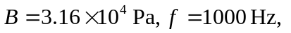
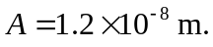 Using Example 16.5, 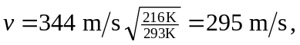 so the pressure amplitude of this wave is 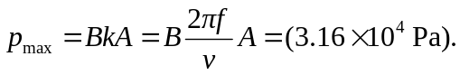
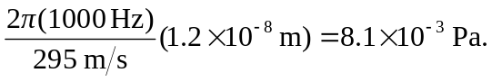 This is 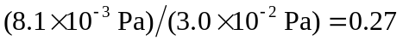 times smaller than the pressure amplitude at sea level (Example 16-1), so pressure amplitude decreases with altitude for constant frequency and displacement amplitude.

